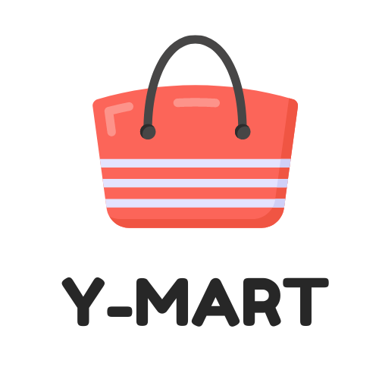

Software Requirements Specifications for

Y-Mart Project

**3-Mar-2023**

**Version 0.1**

**Prepared By   
Vendor Company**

**Change History**

|  |  |  |  |
| --- | --- | --- | --- |
| **Date** | **Version** | **Description** | **Updated By** |
| 11 Nov 2021 | 0.1 | Initial Draft | Yogesh Dahake |

**Document Approvals**

|  |  |  |
| --- | --- | --- |
| **Name** | **Role** | **Signature** |
| John Smith | Business Team/Product Owner |  |

**Table of Contents**

1. Introduction 4

1.1 Purpose of the document 4

1.2 Scope of the project 4

1.3 Stakeholders involved 5

1.4 Overview of the Y-Mart E-commerce portal 6

2. Overall Description 7

2.1 Product perspective 7

2.2 Product functions 8

2.3 User characteristics 9

2.4 Constraints 9

2.5 Assumptions and dependencies 10

2.6 Apportioning of requirements 11

3. Specific Requirements 11

3.1 Functional Requirements 11

3.1.1 Product browsing and searching 11

3.1.2 Product ordering and checkout 12

3.1.3 User account management 12

3.1.4 Payment processing 13

3.1.5 Order tracking and status 14

3.2 Non-functional Requirements 14

3.2.1 Performance requirements 14

3.2.2 Usability requirements 14

3.2.3 Security requirements 15

3.2.4 Compatibility requirements 15

3.2.5 Availability requirements 16

4.Use Cases 16

4.1 Product browsing and searching use case 16

4.2 Product ordering and checkout use case 17

4.3 User account management use case 19

4.4 Payment processing use case 19

4.5 Order tracking and status use case 19

5.System Models 19

5.1 Class diagrams 19

5.2 Sequence diagrams 19

5.3 State diagrams 20

6.Appendices 21

6.1 Glossary of terms 21

6.2 List of acronyms and abbreviations 21

6.3 References and resources 22

# **1. Introduction**

## **1.1 Purpose of the document**

The purpose of this document is to provide a comprehensive set of requirements for the Y-Mart E-commerce portal. It outlines the functional and non-functional requirements for the software system, as well as the constraints and assumptions that impact the development process.

This document serves as a communication tool between the development team and other stakeholders involved in the project, including business analysts, project managers, and technical and non-technical stakeholders. It provides a clear understanding of the requirements for the software system, enabling stakeholders to make informed decisions about the design, development, testing, and deployment of the system.

The requirements outlined in this document are intended to guide the development team in the creation of a high-quality software system that meets the needs of Y-Mart's customers. The document also serves as a baseline for testing and verification, ensuring that the software system meets the desired functionality and quality standards.

In summary, the purpose of this document is to provide a clear and comprehensive set of requirements for the Y-Mart E-commerce portal, enabling stakeholders to make informed decisions about the development and deployment of the software system.

## **1.2 Scope of the project**

The Y-Mart E-commerce portal is an online platform that enables customers to browse and purchase products from the Y-Mart retail store. The scope of this project is to develop a high-quality software system that provides a seamless and intuitive user experience for browsing products, placing orders, and managing user accounts.

The software system includes a website and mobile application, which will be developed for iOS and Android platforms. The website and mobile application will have similar functionality and user interfaces, allowing customers to access the Y-Mart E-commerce portal on multiple devices.

The software system will include the following key features:

• **Product browsing and searching:** Customers can browse products by category, search for specific products, and view detailed product information, including pricing and availability.

• **Order placement and tracking:** Customers can place orders, select shipping options, and track the status of their orders in real-time.

• **User account management:** Customers can create and manage their user accounts, view order history, and manage their shipping and billing information.

• **Payment processing:** The software system will integrate with a third-party payment processing service to securely process customer payments.

• **Inventory management:** The software system will integrate with Y-Mart's inventory management system to ensure accurate product availability and pricing.

The development of the software system will adhere to the Agile methodology, with regular sprints and iterative development cycles. The project timeline will be approximately 12 months, including development, testing, and deployment phases.

The scope of this project does not include the development of a separate inventory management system, as this will be integrated with Y-Mart's existing inventory management system. Additionally, the scope of the project does not include the development of a separate payment processing system, as this will be integrated with a third-party payment processing service.

In summary, the scope of this project is to develop a high-quality software system that provides a seamless and intuitive user experience for browsing and purchasing products from the Y-Mart retail store. The software system includes key features such as product browsing and searching, order placement and tracking, user account management, payment processing, and inventory management. The project will adhere to the Agile methodology and will be completed within a 12-month timeline.

## **1.3 Stakeholders involved**

The following stakeholders will be involved in the development and implementation of the Y-Mart E-commerce portal software system:

**1.3.1 Y-Mart Management**

Y-Mart management will oversee the development and implementation of the software system. They will provide requirements and feedback throughout the development process to ensure that the software system meets the needs of the business and its customers.

**1.3.2 Y-Mart Employees**

Y-Mart employees will be responsible for maintaining the product catalog, managing customer orders, and ensuring that the software system operates smoothly. They will require access to the software system to perform these tasks.

**1.3.3 Customers**

Customers are the primary users of the Y-Mart E-commerce portal software system. They will use the software system to browse products, place orders, and manage their user accounts. It is important that the software system is user-friendly and provides a positive user experience to ensure customer satisfaction.

**1.3.4 Third-Party Payment Processing Service**

The Y-Mart E-commerce portal will integrate with a third-party payment processing service to securely process customer payments. The third-party payment processing service will be responsible for ensuring that customer payment information is securely processed and stored.

**1.3.5 Developers**

The development team will be responsible for the design, development, and implementation of the software system. They will work closely with Y-Mart management and employees to ensure that the software system meets all requirements and specifications.

In summary, the stakeholders involved in the development and implementation of the Y-Mart E-commerce portal software system include Y-Mart management, Y-Mart employees, customers, the third-party payment processing service, and the development team. Each stakeholder plays a critical role in the success of the software system, and their input and feedback will be valuable throughout the development process.

## **1.4 Overview of the Y-Mart E-commerce portal**

The Y-Mart E-commerce portal is an online platform that will allow customers to browse and purchase products offered by Y-Mart. The software system will be designed and developed to provide a seamless user experience and to ensure that customers can easily find and purchase the products they are interested in.

The Y-Mart E-commerce portal will consist of the following main features:

**1.4.1 Product Catalog**

The product catalog will include a comprehensive list of all products offered by Y-Mart. Each product will have a description, price, and image associated with it. Customers will be able to browse and search the product catalog to find products they are interested in.

**1.4.2 User Accounts**

Customers will be able to create user accounts on the Y-Mart E-commerce portal to manage their orders and preferences. User accounts will allow customers to view their order history, track their orders, and save their shipping and billing information for future purchases.

**1.4.3 Shopping Cart**

The shopping cart feature will allow customers to add products to their cart and checkout when they are ready to make a purchase. Customers will be able to view the contents of their shopping cart at any time and make changes to their order before checking out.

**1.4.4 Payment Processing**

The Y-Mart E-commerce portal will integrate with a third-party payment processing service to securely process customer payments. Customers will be able to enter their payment information during the checkout process, and the payment processing service will securely process the payment.

**1.4.5 Order Fulfillment**

Y-Mart employees will be responsible for fulfilling customer orders placed through the Y-Mart E-commerce portal. They will receive order information through the software system and will be responsible for packaging and shipping the products to customers.

In summary, the Y-Mart E-commerce portal will provide customers with a comprehensive online shopping experience, including a product catalog, user accounts, shopping cart, payment processing, and order fulfillment. The software system will be designed and developed to ensure that it is user-friendly and provides a seamless experience for customers.

# **2. Overall Description**

## **2.1 Product perspective**

The Y-Mart E-commerce portal will be a standalone software system that will be designed and developed to provide a seamless online shopping experience for customers. The software system will be developed using modern web development technologies and will be hosted on a cloud platform.

The software system will interact with various external systems to provide a complete online shopping experience for customers. The following external systems will be integrated with the Y-Mart E-commerce portal:

**2.1.1 Product Management System**

The Y-Mart E-commerce portal will integrate with a product management system to receive updated information about the products offered by Y-Mart. The product management system will be responsible for maintaining up-to-date information about product descriptions, pricing, and availability.

**2.1.2 Payment Processing System**

The Y-Mart E-commerce portal will integrate with a third-party payment processing system to securely process customer payments. The payment processing system will be responsible for validating customer payment information and processing payments securely.

**2.1.3 Shipping Management System**

The Y-Mart E-commerce portal will integrate with a shipping management system to track shipments and update customers on the status of their orders. The shipping management system will be responsible for managing the logistics of shipping products to customers.

The Y-Mart E-commerce portal will also interact with various user interfaces to provide a complete online shopping experience for customers. The following user interfaces will be developed as part of the software system:

**2.1.4 Customer Interface**

The customer interface will allow customers to browse and purchase products offered by Y-Mart. Customers will be able to create user accounts, add products to their shopping cart, and complete the checkout process to purchase products.

**2.1.5 Employee Interface**

The employee interface will allow Y-Mart employees to manage customer orders and fulfill customer orders. Employees will be able to view customer order information, update order status, and manage shipping information for orders.

In summary, the Y-Mart E-commerce portal will be a standalone software system that will interact with various external systems and user interfaces to provide a complete online shopping experience for customers. The software system will be developed using modern web development technologies and will be hosted on a cloud platform.

## **2.2 Product functions**

The Y-Mart E-commerce portal will provide the following functions for customers:

**2.2.1 Product Browsing**

Customers will be able to browse the products offered by Y-Mart through various categories and subcategories. Customers will be able to view product descriptions, images, and pricing information.

**2.2.2 Product Search**

Customers will be able to search for products by keyword, product name, category, or subcategory. The search function will return relevant search results based on the customer's query.

**2.2.3 Product Ordering**

Customers will be able to add products to their shopping cart and complete the checkout process to purchase products. The checkout process will include steps for shipping information, payment information, and order confirmation.

**2.2.4 Customer Account Management**

Customers will be able to create user accounts to store their personal information and order history. Customers will be able to view their order history, update their personal information, and manage their user account settings.

The Y-Mart E-commerce portal will provide the following functions for Y-Mart employees:

**2.2.5 Order Management**

Employees will be able to manage customer orders, view order information, and update order status. Employees will also be able to manage shipping information for orders.

**2.2.6 Product Management**

Employees will be able to manage product information, including product descriptions, images, and pricing information. Employees will also be able to add new products and remove existing products from the Y-Mart product catalog.

**2.2.7 Customer Support**

Employees will be able to provide customer support to customers through the Y-Mart E-commerce portal. Employees will be able to respond to customer inquiries and resolve customer issues related to their orders.

In summary, the Y-Mart E-commerce portal will provide various functions for customers and Y-Mart employees, including product browsing, search, ordering, account management, order management, product management, and customer support.

## **2.3 User characteristics**

The Y-Mart E-commerce portal is designed to serve a wide range of users, including:

• Customers who are interested in browsing and purchasing products from Y-Mart. These users may have varying levels of technical expertise and familiarity with online shopping.

• Y-Mart employees who are responsible for managing customer orders, product information, and customer support. These users will require access to administrative functions within the Y-Mart E-commerce portal.

The following are some of the key user characteristics that have been considered in the design of the Y-Mart E-commerce portal:

• Technical Proficiency: Customers may have varying levels of technical proficiency and experience with online shopping. The portal has been designed to be user-friendly and intuitive, with clear navigation and easy-to-use features.

• Language: The Y-Mart E-commerce portal will be available in English language only.

• Accessibility: The portal will be accessible to users with a range of physical abilities, and will comply with accessibility standards.

• Security: The portal will require users to create user accounts and log in to access certain features, such as order history and account management. The portal will implement security measures to protect user data and prevent unauthorized access.

In summary, the Y-Mart E-commerce portal is designed to serve a range of users, including customers and Y-Mart employees. The portal has been designed with consideration for user characteristics such as technical proficiency, language, accessibility, and security.

## **2.4 Constraints**

The development of the Y-Mart E-commerce portal is subject to a number of constraints that will need to be considered during the design and implementation process. These constraints include:

**• Technology Limitations:** The portal must be developed using technologies that are compatible with the existing Y-Mart infrastructure. Additionally, the portal must be compatible with a range of devices and operating systems, including desktop and mobile platforms.

**• Time Constraints:** The development of the Y-Mart E-commerce portal is subject to a tight timeline, with a launch date of December 31, 2023. This will require careful planning and execution to ensure that the portal is completed on time.

**• Budget Constraints:** The development of the portal is subject to a fixed budget, which will need to be carefully managed throughout the development process.

**• Legal and Regulatory Constraints:** The portal must comply with all relevant laws and regulations, including data protection and privacy regulations.

**• Performance and Scalability Constraints:** The portal must be designed to handle high levels of traffic and usage, and must be scalable to accommodate future growth.

**• Security Constraints:** The portal must implement security measures to protect user data and prevent unauthorized access.

In summary, the development of the Y-Mart E-commerce portal is subject to a number of constraints, including technology limitations, time and budget constraints, legal and regulatory requirements, performance and scalability considerations, and security constraints. These constraints will need to be carefully managed throughout the development process to ensure that the portal is delivered on time, on budget, and in compliance with all relevant requirements.

## **2.5 Assumptions and dependencies**

The development of the Y-Mart E-commerce portal is based on a number of assumptions and dependencies that are important to consider during the design and implementation process. These include:

**Assumptions:**

• The Y-Mart E-commerce portal will be developed in-house by the Y-Mart development team.

• The portal will be developed using existing Y-Mart infrastructure and technology stack.

• The portal will be hosted on Y-Mart servers.

• The Y-Mart development team has the necessary skills and resources to complete the project.

• The portal will be launched on December 31, 2023, as planned.

**Dependencies:**

• The Y-Mart E-commerce portal is dependent on the availability and functionality of existing Y-Mart systems and infrastructure, including databases, servers, and networks.

• The portal is dependent on third-party software and services, such as payment gateways and shipping providers.

• The development team is dependent on timely access to resources and information, including technical documentation and design specifications.

It is important to consider these assumptions and dependencies during the development process to ensure that the Y-Mart E-commerce portal is delivered on time and in compliance with all relevant requirements. Any changes to these assumptions or dependencies should be communicated and addressed in a timely manner to avoid delays or issues during the development process.

## **2.6 Apportioning of requirements**

The requirements for the Y-Mart E-commerce portal have been apportioned into different phases to enable a phased approach to development and deployment. The apportioning of requirements is based on the criticality and complexity of each requirement, as well as the dependencies between them.

The apportioning of requirements is as follows:

**Phase 1: Basic E-commerce functionality**

• User registration and login

• Product browsing and search

• Shopping cart and checkout

• Payment integration

• Basic order management

**Phase 2: Advanced E-commerce functionality**

• Product recommendations and upselling

• Customer reviews and ratings

• Loyalty program integration

• Advanced order management

• Social media integration

**Phase 3: Mobile application development**

• Native mobile application development for iOS and Android platforms

• Integration with existing E-commerce functionality

• Mobile-specific features, such as push notifications and location-based services

The apportioning of requirements enables a gradual and phased approach to development, allowing for incremental testing and validation of features. Each phase will be delivered based on a fixed timeline and budget, and the final product will incorporate all of the required features and functionality.

# **3. Specific Requirements**

## **3.1 Functional Requirements**

### **3.1.1 Product browsing and searching**

The Y-Mart E-commerce portal shall provide a user-friendly interface for customers to browse and search for products. The following requirements must be met:

1. The portal shall allow customers to search for products by keyword, category, brand, and price range.
2. The portal shall display search results in an organized and easy-to-navigate format.
3. The portal shall provide filters to allow customers to refine their search results based on product attributes, such as color, size, and material.
4. The portal shall display product information, including product name, description, price, availability, and images, in a clear and concise manner.
5. The portal shall provide recommendations for related or complementary products to enhance the customer's shopping experience.
6. The portal shall allow customers to add products to their cart directly from the search results page.

For example, a customer searching for "running shoes" should be able to filter the results by brand, size, and color, and view product information such as the shoe's description, price, and availability. The customer should also be able to easily add the desired product to their cart and continue browsing or proceed to checkout.

### **3.1.2 Product ordering and checkout**

The Y-Mart E-commerce portal allows users to place orders and checkout using various payment methods. The following requirements must be met:

1. The user must be able to add products to the cart and proceed to checkout.
2. The user must be able to view the cart and modify the quantity of items or remove items from the cart.
3. The user must be able to select a payment method such as credit/debit card, net banking, or cash on delivery.
4. The system must verify the availability of the selected products before placing the order.
5. The system must generate an order confirmation page with a unique order ID and details of the ordered products.
6. The system must send an order confirmation email to the user with the order details and estimated delivery time.
7. The user must be able to track the status of the order in real-time.
8. The system must process the payment securely and notify the user in case of any payment failures.
9. The system must provide an option for the user to cancel the order before the order is shipped.

Example: A user adds a mobile phone to the cart and proceeds to checkout. The system verifies the availability of the selected mobile phone and displays the total price with taxes and shipping charges. The user selects the payment method as credit card and enters the card details. The system processes the payment securely and generates an order confirmation page with a unique order ID and details of the ordered products. The system sends an order confirmation email to the user with the order details and estimated delivery time. The user can track the status of the order in real-time and can cancel the order before it is shipped.

### **3.1.3 User account management**

This section outlines the functional requirements related to user account management for the Y-Mart E-commerce portal.

* User Registration

The Y-Mart E-commerce portal shall provide users with the ability to register for an account using their email address or social media account.

* Login

Users shall be able to log in to their account using their email address and password or their social media account.

* Forgot Password

The portal shall provide users with the option to reset their password in case they forget it. This feature shall send an email to the user's registered email address containing a link to reset their password.

* Account Information Management

Users shall be able to manage their account information, including their personal details, delivery address, and payment methods.

* Order History

The portal shall maintain a record of all the orders placed by the user. Users shall be able to view their order history and the status of their orders.

* Wish List

The portal shall allow users to create and manage their wish list. Users shall be able to add and remove products from their wish list and receive notifications when a product from their wish list is available.

* Product Reviews and Ratings

Users shall be able to write reviews and give ratings for products they have purchased. These reviews and ratings shall be visible to all users browsing the portal.

* Newsletter Subscription

Users shall have the option to subscribe to the portal's newsletter to receive regular updates on new products, discounts, and promotions.

### **3.1.4 Payment processing**

The Y-Mart E-commerce portal will facilitate secure and convenient payment processing for customers. The following are the functional requirements related to payment processing:

1. Payment Options: The portal will support multiple payment options, including credit/debit cards, net banking, digital wallets, and cash on delivery.
2. Payment Gateway Integration: The portal will integrate with a reliable and secure payment gateway to ensure the safe transfer of funds from the customer's account to the merchant's account.
3. Transaction Status Notification: The portal will provide real-time transaction status updates to customers via email and SMS.
4. Refund and Cancellation Policies: The portal will have clear and concise refund and cancellation policies to provide customers with a hassle-free experience.
5. Payment Security: The portal will comply with industry-standard payment security protocols such as SSL encryption, two-factor authentication, and PCI DSS compliance to protect customer payment information from unauthorized access.

### **3.1.5 Order tracking and status**

<Add content here >>

## **3.2 Non-functional Requirements**

Non-functional requirements describe how the system should behave, rather than what it should do. These requirements typically involve factors such as performance, reliability, scalability, and security. Here are some examples of non-functional requirements for the Y-Mart e-commerce portal:

### **3.2.1 Performance requirements**

Performance requirements are a subset of non-functional requirements that describe how the system should perform in terms of speed, scalability, and capacity. Here are some examples of performance requirements for the Y-Mart e-commerce portal:

1. Response time: The system should have a maximum response time of 3 seconds per page load, even under heavy load.
2. Throughput: The system should be able to handle a minimum of 10,000 concurrent users at peak times, with a minimum of 100 transactions per second.
3. Scalability: The system should be designed with scalability in mind, with the ability to add additional resources (such as servers) as required to handle increased traffic.
4. Load testing: The system should be subjected to load testing to ensure that it can handle the expected number of users and transactions.
5. Caching: The system should make use of caching to reduce response times and improve overall performance.
6. Database optimization: The system should be designed with database optimization in mind, to ensure that database queries are efficient and do not slow down the system.

Overall, performance requirements are critical for ensuring that the Y-Mart e-commerce portal can handle the expected volume of traffic and provide a fast and responsive user experience for customers.

### **3.2.2 Usability requirements**

Usability requirements describe how user-friendly and easy to use the system should be. Here are some examples of usability requirements for the Y-Mart e-commerce portal:

1. Navigation: The system should have intuitive and easy-to-use navigation, with clear menus and links that allow users to easily find what they are looking for.
2. Search functionality: The system should have a powerful and accurate search functionality that allows users to quickly find products and information.
3. Mobile responsiveness: The system should be mobile responsive, with a layout and design that adapts to different screen sizes and resolutions.
4. Accessibility: The system should be designed with accessibility in mind, ensuring that it can be used by users with disabilities or using assistive technologies.
5. Error messages: The system should display clear and helpful error messages when something goes wrong, with instructions on how to fix the problem.
6. Consistency: The system should be consistent in terms of layout, design, and terminology, with a consistent look and feel across all pages and sections.

Overall, usability requirements are critical for ensuring that the Y-Mart e-commerce portal is easy to use and provides a positive user experience for customers.

### **3.2.3 Security requirements**

Security requirements describe how the system should protect sensitive information, prevent unauthorized access, and ensure the integrity and confidentiality of data. Here are some examples of security requirements for the Y-Mart e-commerce portal:

1. Authentication: The system should require users to authenticate themselves before accessing any sensitive information, using a strong password policy and multifactor authentication for added security.
2. Authorization: The system should implement role-based access control, ensuring that users can only access the information and functionality that they are authorized to use.
3. Encryption: The system should use strong encryption techniques to protect sensitive information such as credit card details, user account information, and order history.
4. Audit trails: The system should maintain detailed audit trails of all user activities, including logins, transactions, and system changes, to ensure accountability and facilitate investigation in case of security incidents.
5. Vulnerability scanning: The system should regularly undergo vulnerability scanning and penetration testing to identify and address any security vulnerabilities and ensure ongoing protection.
6. Disaster recovery: The system should have a robust disaster recovery plan in place to ensure that data can be quickly and securely restored in case of a security breach or other disaster.

Overall, security requirements are critical for ensuring that the Y-Mart e-commerce portal can protect sensitive information and prevent unauthorized access, providing a safe and secure environment for customers to conduct their business.

### **3.2.4 Compatibility requirements**

1. **Operating System Compatibility**: The Y-Mart E-commerce portal shall be compatible with the following operating systems:
   1. Windows 10
   2. MacOS High Sierra or later versions
   3. Ubuntu 20.04 or later versions
2. **Browser Compatibility:** The Y-Mart E-commerce portal shall be compatible with the following browsers:
   1. Google Chrome (latest version)
   2. Mozilla Firefox (latest version)
   3. Apple Safari (latest version)
   4. Microsoft Edge (latest version)
3. **Mobile Compatibility:** The Y-Mart E-commerce portal shall be optimized for mobile devices with the following specifications:
   1. iOS 12 or later versions
   2. Android 9 or later versions
   3. Screen size of at least 4 inches
4. **Database Compatibility:** The Y-Mart E-commerce portal shall be compatible with the following database management systems:
   1. MySQL 8 or later versions
   2. PostgreSQL 12 or later versions
   3. MongoDB 4 or later versions
5. **Third-Party Integrations Compatibility:** The Y-Mart E-commerce portal shall be compatible with the following third-party integrations:
   1. PayPal payment gateway
   2. Google Analytics for website traffic analysis
   3. Facebook Pixel for retargeting advertisements

Note: The above compatibility requirements are subject to change based on any updates or changes to the operating systems, browsers, and third-party integrations mentioned.

### **3.2.5 Availability requirements**

The Y-Mart E-commerce portal must be highly available to ensure uninterrupted service for users. The following availability requirements must be met:

1. The system should be available 24x7, except during maintenance windows which should be scheduled in advance and communicated to the users.
2. The system uptime should be at least 99.99% in a year. This means that the system can be down for no more than 52 minutes and 35 seconds per year.
3. The system should be able to handle peak traffic loads during holidays and sales events without any degradation in performance.
4. In case of any unplanned downtime, the system should be able to recover and restore normal operations within 30 minutes.
5. The system should have built-in redundancy and failover mechanisms to ensure high availability in case of hardware or software failures.

Example: To meet the availability requirements, the Y-Mart E-commerce portal will be hosted on a cloud platform that offers automatic scaling and load balancing. The system will have multiple instances deployed in different geographic regions to ensure redundancy and failover. Additionally, the system will have a monitoring and alerting mechanism to notify the operations team of any performance or availability issues. Regular maintenance windows will be scheduled during off-peak hours to minimize any impact on users.

# **4.Use Cases**

## **4.1 Product browsing and searching use case**

Product browsing and searching use case:

Description: This use case describes the process of browsing and searching for products on the Y-Mart e-commerce portal.

Actors:

• Customer: A user who visits the Y-Mart e-commerce portal to browse and purchase products.

• System: The Y-Mart e-commerce portal that provides product browsing and searching functionality.

Pre-conditions:

• The customer has internet access.

• The customer has navigated to the Y-Mart e-commerce portal.

Post-conditions:

• The customer can view a list of products matching their search criteria.

• The customer can add products to their cart.

Basic Flow:

1.The customer navigates to the search bar on the Y-Mart e-commerce portal.

2.The customer enters keywords for the product they want to search for.

3.The system retrieves and displays a list of products matching the search criteria.

4.The customer can filter the list of products by various parameters such as price, rating, etc.

5.The customer can click on a product to view its details and add it to their cart.

Alternative Flows:

1a. If the customer does not enter any keywords in the search bar, the system displays a default list of products.

3a. If no products match the customer's search criteria, the system displays a message informing the customer that no products were found.

5a. If the customer does not want to add the product to their cart, they can continue browsing for other products.

Exceptions:

If the system is down or experiencing technical difficulties, the customer will be unable to browse or search for products. An error message will be displayed.

## **4.2 Product ordering and checkout use case**

Description: This use case describes the process of ordering products and checking out on the Y-Mart e-commerce portal.

Actors:

• Customer: A user who visits the Y-Mart e-commerce portal to browse and purchase products.

• System: The Y-Mart e-commerce portal that provides the ordering and checkout functionality.

Pre-conditions:

• The customer has a registered account on the Y-Mart e-commerce portal.

• The customer has added products to their cart.

• The customer has selected a payment method.

Post-conditions:

• The customer receives an order confirmation email.

• The system updates the inventory and customer order history.

**Basic Flow:**

1.The customer navigates to their cart and selects the "Checkout" button.

2.The system displays the customer's cart summary, including the total amount due.

3.The customer confirms the items and quantity, and enters their shipping and billing information.

4.The system displays the payment options and the customer selects their preferred payment method.

5.The system processes the payment and displays the order confirmation page.

6.The system sends an order confirmation email to the customer's registered email address.

**Alternative Flows:**

2a. If the customer wants to modify their cart, they can navigate back to the product listing page or cart page to make changes.

3a. If the customer wants to ship to a different address, they can enter a new shipping address.

4a. If the payment is declined, the system displays an error message and prompts the customer to try another payment method.

**Exceptions:**

7.If the customer is not logged in, they will be prompted to log in or create an account before they can proceed to checkout.

8.If the system experiences technical difficulties during payment processing, the customer will be unable to complete the checkout process. An error message will be displayed.

## **4.3 User account management use case**

## **4.4 Payment processing use case**

## **4.5 Order tracking and status use case**

# **5.System Models**

## **5.1 Class diagrams**

The class diagram is a visual representation of the classes and relationships in the Y-Mart e-commerce portal.

**Use case: Product ordering and checkout use case**  
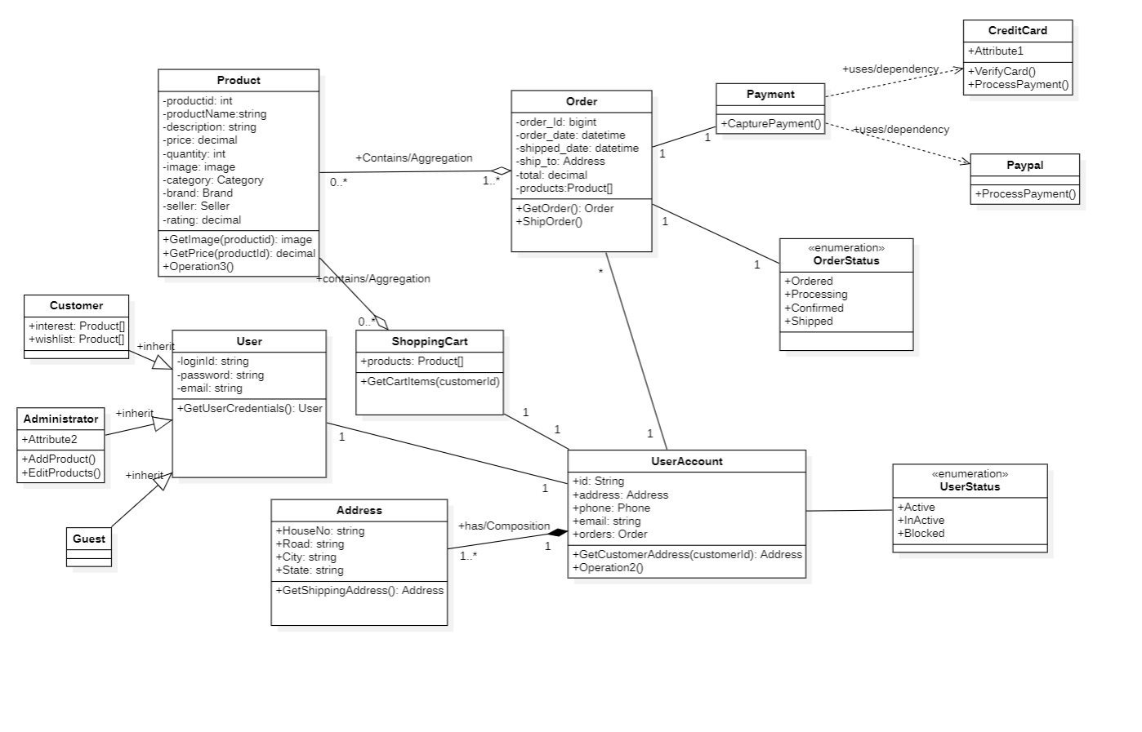

## **5.2 Sequence diagrams**

The sequence diagram is a visual representation of the interactions between objects in a specific scenario or use case in the Y-Mart e-commerce portal.  
**Use case: Product ordering and checkout use case**  
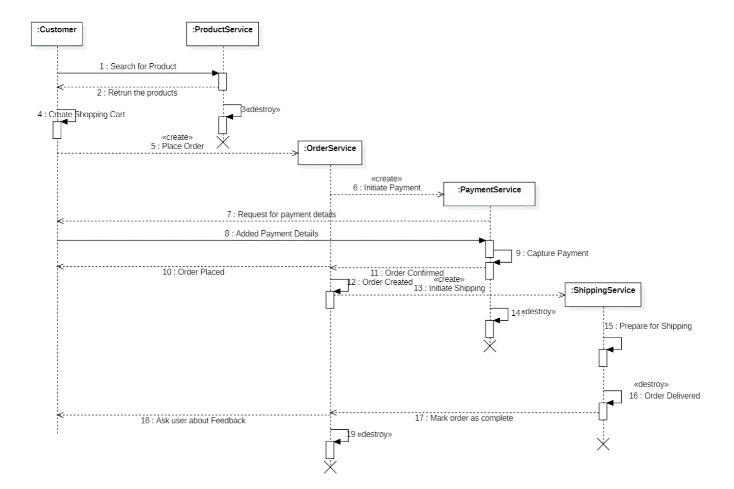

## **5.3 State diagrams**

A state diagram is a visual representation of the states and transitions of an object or a group of objects in the Y-Mart e-commerce portal.  
**Use case: Product ordering and checkout use case**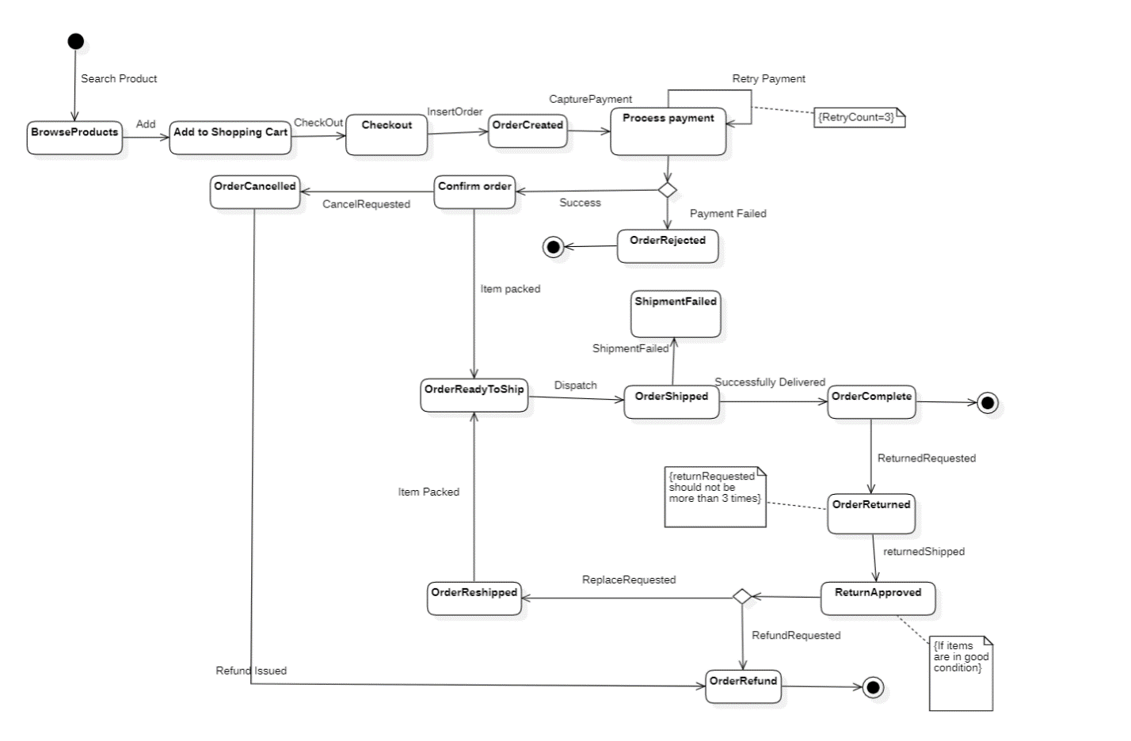

# **6.Appendices**

## **6.1 Glossary of terms**

* E-commerce: The buying and selling of products or services over the internet.
* SRS: Software Requirements Specification, a document that describes the requirements for a software system.
* Stakeholder: A person or organization that has an interest or concern in a software system.
* Use case: A description of a specific scenario or interaction between the user and the system.
* Class diagram: A visual representation of the classes and relationships in a software system.
* Sequence diagram: A visual representation of the interactions between objects in a specific scenario or use case.
* State diagram: A visual representation of the states and transitions of an object or a group of objects in a software system.

## **6.2 List of acronyms and abbreviations**

* API: Application Programming Interface
* CSS: Cascading Style Sheets
* HTML: Hypertext Markup Language
* HTTPS: Hypertext Transfer Protocol Secure
* JSON: JavaScript Object Notation
* SQL: Structured Query Language

## **6.3 References and resources**

* IEEE Recommended Practice for Software Requirements Specifications: https://ieeexplore.ieee.org/document/830737
* Unified Modeling Language (UML) specification: https://www.uml-diagrams.org/
* OWASP Top Ten Project: https://owasp.org/Top10/
* Payment Card Industry Data Security Standard (PCI DSS): https://www.pcisecuritystandards.org/